UNIVERSITY OF CAPE TOWN: Centre for Film and Media Studies

RESEARCH ETHICS: STUDENT/SUPERVISOR JOINT STATEMENT

This form should be completed by the student researcher and then co-signed by student and supervisor: Tick the YES or NO box, and provide details where appropriate. Please read the UCT Code for Research involving Human Subjects before completing the form. Ask your supervisor for clarification and help if needed.

Name:
Title of project:
Course code:

Supervisor:

- Have you read the UCT Code for Research involving Human Subjects? (available from the CFMS website) | YES | NO

- Does your research make use of human subjects as sources of data?  And/or Does your research focus on social media data? | YES | NO

- State your research questions/focus, and give a brief outline of your plans for data collection. Please attach your full proposal to this application where possible (MA and PhD students)

- Will participants (research subjects) in the research have reasonable and sufficient knowledge about you, your background and location, and your research intentions?  Describe briefly below how such information will be given to them. If there is any reason for withholding any information from participants about your identity and your research purpose, explain this in detail below. | YES | NO

- Will you secure the informed consent of all participants in the research? Describe how you will do this. If your answer is NO, give reasons below. Will this consent be obtained in writing? If not, give reasons. | YES | NO

- In the case of research involving minors, will you obtain the consent of parents/guardians? If your answer is NO, give reasons below. If your answer is YES, briefly describe how consent will be given. Note that you may need further approval from the WCED for research conducted in schools. | YES | NO

- In the case of research involving minors, will you obtain the consent of the children? If your answer is YES, briefly describe how this consent will be obtained from the children. If your answer is NO, give reasons below. | YES | NO

- Are you able to offer privacy and confidentiality to participants if they wish to remain anonymous? If you answer YES then give details below explaining what steps you will take to ensure participants’ confidentiality. If there are any aspects of your research where there might be difficulties or problems with regard to protecting the confidentiality and rights of participants and honouring their trust, explain this in detail below. | YES | NO

- Are there any foreseeable risks of physical, psychological or social harm to participants that might result from or occur in the course of the research? If your answer is YES, outline below what these risks might be and what preventative steps you plan to take to prevent such harm from being suffered. | YES | NO

- Are there any foreseeable risks of harm to UCT or to other institutions that might result from or occur in the course of the research? e.g., legal action resulting from the research, the image of the university being affected by association with the research project? If your answer is YES, give details and state below why you think the research is worthwhile nonetheless. | YES | NO

- Are there any other ethical issues that you think might arise during the course of the research? (e.g. with regard to conflicts of interests amongst participants and/or institutions) If your answer is YES, give details and explain what you plan to do about it. | YES | NO

Signed: _____________ _____________
Student: Supervisor:

Date: Date:

Ethical decision-making in creative projects

Checklist:
- I have discussed my research plan and any ethical issues with my supervisor.
- My supervisor has approved my methodology and signed this form.
- Each subject (interviewee) will sign a release (use attached form and adapt as necessary)
- I undertake to contact my supervisor for advice regarding any further ethical issues that may arise.
- I undertake to submit these releases with the final film .

Research focus
- In the space below state your research question/focus, give a brief overview of your planned method. Also outline how you will interact with the subjects who will participate in the project.

Your methodology needs to be reviewed and approved by the research committee if it involves any ethically complex situations. Please indicate whether you plan to do any of the following:
1. Filming or interviews with people who cannot legally sign their own consent (e.g. Under 18, mentally handicapped, under influence of substance) Y/N
2. Hidden camera filming, where subject cannot consent because they're not aware of filming Y/N
3. Filming that could endanger the safety of subject(s) or crew (e.g. filming from moving vehicles, stunts, adventure/adrenalin sports, 'challenges' - e.g. As in a reality show) Y/N
4. Filming of activities that are sensitive, incriminating or potentially damaging to subject's reputation (e.g. filming real drug use, 'confessions' about criminal activities etc, sex/related activities/discussions, interviews about past criminal or compromising activities) Y/N
5. Filming of medical or other experiments Y/N
6. Filming of medical, psychiatric or psychological treatment or procedures Y/N

Signed:
Student:
Co–signed:
Supervisor:
Date:
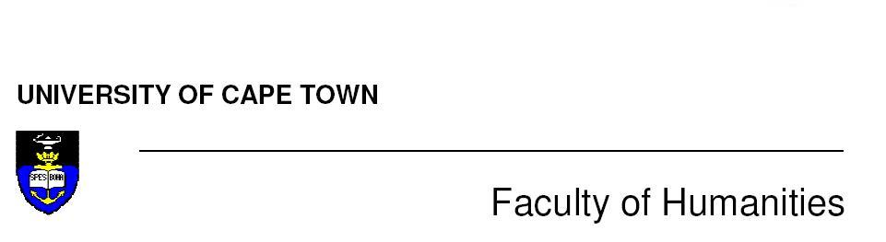

Consent Form

Title of research project:
Names of principal researcher(s):
Department/research group address: Centre for Film and Media Studies, University of Cape Town (UCT), Private Bag, Rondebosch, 7700.
Telephone:

Email:

Name of Participant:

Nature of the Research:

Participant’s Involvement:
- What’s involved:

- Risks:

- Benefits:

- I agree to participate in this research project.
- I have read this consent form and the information it contains and had the opportunity to ask questions about it.
- I agree to my responses being used for research on condition that my privacy is respected, subject to the following:
  - Will be used in aggregate form only (only as part of collected data), so that I will not be personally identifiable (identity anonymous in research project and archived transcriptions of data).
- I understand that I am under no obligation to take part in this project.
- I understand that I have the right to withdraw from this project at any stage.

Signature of participant: ________________________________________
Signature of Parent/Guardian (if participant is under 18 years of age):_________________________________________________________
Name of Parent/Guardian:_______________________________________
Signature of person giving consent: _________________________________
Signature of person(s) who sought consent:___________________________
Name of person(s) who sought consent: ___________ Date:______________
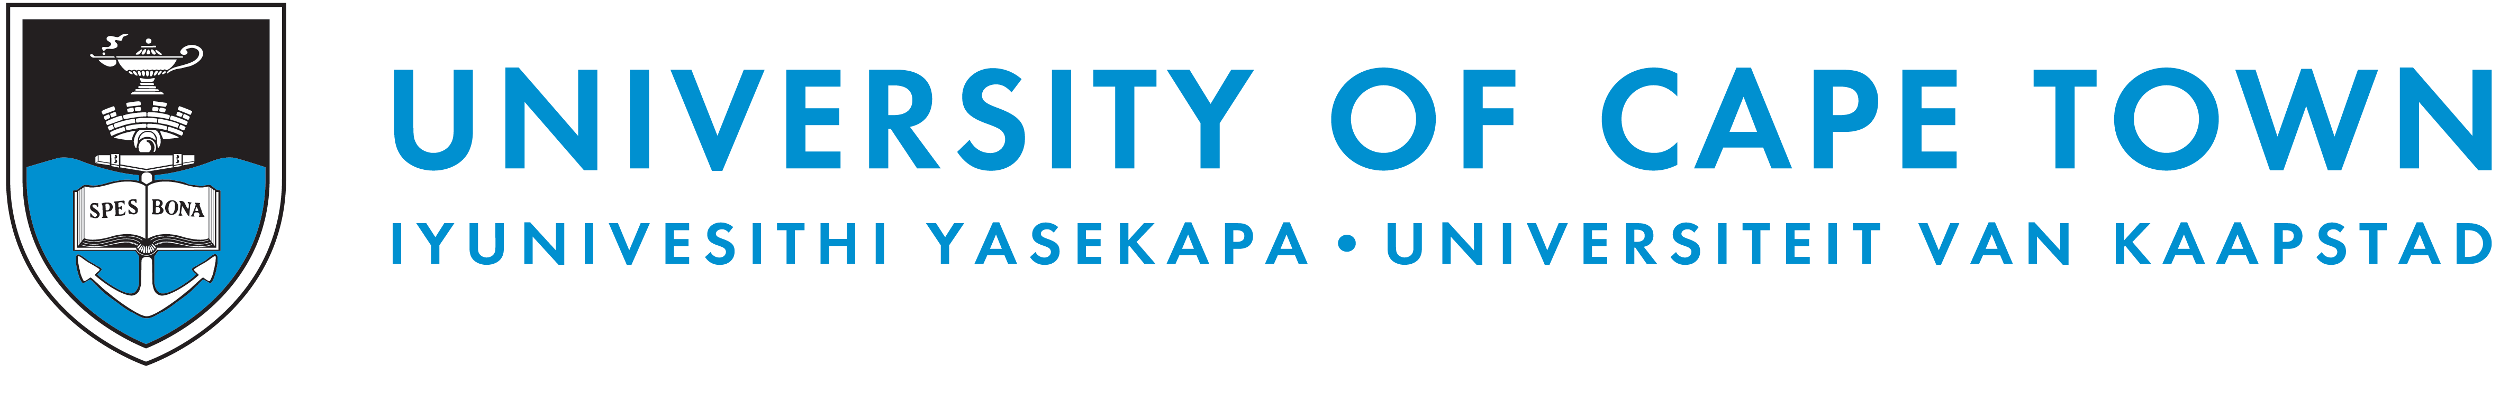

Name of assignment__________________________________________

Film & Media Department University of Cape Town

1. I agree to be interviewed for the purposes of the student assignment named above.

2. The purpose and nature of the interview has been explained to me, and I have read
the assignment and/or information sheet as provided by the student.

3. I agree that the interview may be electronically recorded.

4. Any questions that I asked about the purpose and nature of the interview and
assignment have been answered to my satisfaction.

5. Choose a), b) or c):
a) I agree that my name may be used for the purposes of the assignment only and not
for publication.
OR
b) I understand that the student may wish to pursue publication at a later date and my
name may be used.
OR
c) I do not wish my name to be used or cited, or my identity otherwise disclosed, in
the assignment.

Name of interviewee_______________________________________

Signature of interviewee____________________________________

Date______________________

6. I have explained the project and the implications of being interviewed to the
interviewee and I believe that the consent is informed and that he/she understands the
implications of participation.

Name of interviewer________________________________________

Signature of interviewer_____________________________________

Date____________________

--------------------------------------------------------------------------------------------- >>> cut here

For updates and further information please contact the student:_________________________
Email:________________________________
Cellphone number: _____________________________________
He/she will inform you about where to view the final project.
Thank you for your participation and support of UCT Film and Media Studies students.

Ethical decision-making and the study of social media
If you are planning to collect or analyse any kind of social media data you should complete the departmental ethics form with your supervisor. At least in the initial stages of your research until your proposal has passed ethics review you should consider all social media research to be covered by UCT’s ‘human subjects’ rules.

You will also need to read through this AoIR document and use it to guide your decisions. It won’t necessarily provide rigid regulations, but will help you develop the ethical principles which will help you think through the various decisions you'll need to make in the course of your research. This should be an ongoing process, rather than a one-off procedure.

Markham, A., & Buchanan, E. (2012). Ethical Decision-Making and Internet Research: Version 2.0: Recommendations from the AoIR Ethics Working Committee. Retrieved February 12, 2013, from http://aoir.org/reports/ethics2.pdf
The decisions you will make regarding the need to gain consent, anonymisation strategies etc, all depend on the exact nature of the study and the contexts you're studying. Don’t simply assume that you can ignore ethical considerations simply because you’re analysing social media texts which are publicly accessible: “public and private as a clearly recognizable binary no longer holds in everyday practice" (Markham & Buchanan, 2012) .
A key issue to remember is that dissertations, research reports, and papers are increasingly publically accessible to anyone who can use a search engine.

Case study: I want to analyse journalists' and journalism students’ use of social media. I’m interested in their use of Twitter, Facebook and blogs and how they interact with their readers.
A good principle is to try to maintain contextual integrity, which involves thinking carefully about what people might reasonably expect from you in a particular context. The hard part here involves making sure you understand the ‘insider’ expectations that inform other people’s behaviour in that context as well.

For example some famous celebrity journalist might well be considered a public figure, who can reasonably expect scrutiny from the public. Also, that person wouldn't have any particular expectations of you.

If the person is a student in your journalism class, or was a colleague of yours while you were an intern, you have a relationship with them and this changes the context. Think about it this way - if you bumped into them in the lecture theatre or in the newsroom they would likely expect you to greet or chat and to introduce yourself and your study and ask permission before you start treating them as data.

In addition, institutions like universities often have rules about doing research with their students. Check these and get permission where necessary.
Another aspect of contextual integrity involves understanding their practices in relation to the site/s you're studying - do you need to log in, have a friends relationship to access their profile? Even if you don't need to log in to see their page, they might not realise how public it is. If they mostly use the internet on a cellphone they may not even see the privacy options on their interface. Finally a journalist's expectations about their Twitter stream may be very different to their expectations about their family photos on Facebook … or their Grindr profile.
Then think about three principles – the potential to harm and help, power and vulnerability, and personally identifiable information.
Potential to harm / help
Is there any potential for harm to the journalism student? i.e. if you write a scathing critique of the student and someone finds it when they do a Google search, could it harm them and their career prospects in some way?
Is there potential to help the journalist by telling them about your research? i.e. if you write something that could be good for their reputation, help them get promoted etc.

Power
Is there a significant power gradient or particular vulnerability involved in writing about this person? i.e. very different power relationships apply between you and a student in your tutorial group (who is subject to your grading decisions) vs. a journalist at The New York Times.

Personally identifiable information?
If you download and analyse anonymised aggregate data from blogs, social media etc, permissions are not required. "Of the 20 journalistic blogs in the sample, 10% included comment spam promoting diet pills."

As soon as you discuss individual case studies, and particularly if you want to use direct quotes from individuals the situation becomes a bit trickier. A direct quote run through a Google search can often be used to identify the individual even if you anonymise. I would recommend not only getting permission but also chatting to the person and making sure they understand the fact that it might be difficult to anonymise their data i.e. there may only be one journalism student from Piketburg in the class at UCT.

Case study: I want to analyse the discourse about race and gender in the Facebook group of a group of student activists .
Here you should aim to maintain contextual integrity. In this case it’s not only your relationship with individual participants but a more demanding task of understanding the context created by interacting in that group. The way to achieve that is by studying the way the group is set up and understanding its written and unwritten rules.

Social media users are prolific and generate huge amounts of data which is not always easy to collect systematically if you don’t have proper training or use the correct tools. It’s particularly important to avoid a ‘smash and grab’ approach – grabbing a juicy piece of data without spending the time to understand it in context and to see whether it is a useful case study for qualitative research, or whether it can be treated as a representative text in a quantitative study.

Platform rules: Check the Facebook Terms of Service and apply for any necessary permissions. Be aware that these change from time to time. Consult your supervisor before deciding to break the Terms of Service, even if you think they are unethical. You could lose access to your research site completely if you don’t.

Group rules: Is the group set up as a members’ only group, or as a group where anyone can publish? Requiring membership is a strong signal that the group will have specific expectations about privacy. You should apply to join the group and signal that you are also asking for permission to conduct a research project. Find a way of informing the group and especially its administrators about your project e.g. set up a research blog and link to it.

The exact role you play will depend on your research objectives, but in most cases you should aim to play a relatively active role in the group and work hard to understand group norms, practices, and discourse, much as a group ‘insider’ would. You can ask questions and keep mentioning your research to ensure that new members or those who didn’t see your initial application are aware of your project. When you have something written which you want to share with them, upload it on your blog or email it to group administrators or key informants and ask for comments.

If you are going to write any individual case studies or quote people from the group you need to take care to get individual permission or, if this is not possible, take steps to protect the anonymity of members.

Potential to harm/help
Are the activists planning illegal activities? Could your research expose them to unwanted state scrutiny? Are there others who many be harmed by their actions? Remember that your own friends list and list of groups you belong to can identify a group or individuals even when you have tried to anonymise the name of the group and its members in your dissertation and publications. It’s usually better to complete your own training as a researcher before taking on a complex project such as this.

Power
Is there something about you (university or political party affiliation, language, ethnic identity) which might mean that group members’ interactions with you might be forced, not voluntary, or unrepresentative?

Personally identifiable information
Do a Google search to see whether messages posted to the group can be recovered via a search engine. Remember that the search engine index often changes. Think about changing names, not using profile pictures, and tracing any photographs (so that the picture can be used in your analysis without identifying the people in the photograph). What will happen to the unanonymised data you initially collected? How will you look after your data when your research project is complete?

