Department for the Study of Religions



POSTGRADUATE HANDBOOK

2021

WELCOME!

Welcome to the Department for the Study of Religions! We hope that your studies with us will be fulfilling and beneficial.
This booklet is intended to give you basic information which will help familiarise you with our staff, our department and the requirements for completing your studies as efficiently and painlessly as possible.

Contents
 | Where to Go – Places to Know |  | 3
 | Who’s Who |  | 4
 | Communicating with You |  | 7
 | Solving Problems |  | 9
 | Submission of Assignments |  | 11
 | The Honours Research Project |  | 12
 | The Masters Programme |  | 15
 | The PhD Programme |  | 21
 | 2021 Deadlines |  | 26
 | 2021 Course List |  | 28
 | Emergency Numbers |  | 29
 | Appendices |  | 30-43
- Submission Checklists 30-36
- Postgraduate Programmes 37
- Essay Coversheet 38
- Term Dates 39
- Department Events/Activities 39
- PG Presentation Days 40
- Ethics Procedures 41
- Timetable 42-43

Additional Resources: Can be found on REL PG Vula site or requested from Tasneem Wise (Tasneem.Wise@uct.ac.za)
- UCT Digital upload of Masters dissertations FULL GUIDE for submission instructions
- PhD Student Examination Guide for submission instructions
- Guides for PG Students

Where to Go – Places to Know
The Department
The Department of Religious Studies is on the fifth floor of the Robert Leslie Social Science building (LS5.40 and LS5.36).
Most seminars and meetings are held in the postgrad seminar room (LS5.67).
Postgraduate students are welcome to use the religious studies tea room (LS5.55). There is an honour system in place if you wish to join the tea club. Please contact Jackie Stoffels (LS5.40) in this regard
All faculty grad administration is on the 1ST floor of the Beattie Building, main reception area
Leslie Postgrad Hub: 6th floor, Robert Leslie building. There is a space for the Humanities postgrads in the Leslie building. It is shared by Sociology, Politics, Religious Studies and Social Development students. There are networked cubicles, a tea room, tutor rooms and some great outside spaces and balconies. There are also lockers for your use.
Postgrad computer lab: building next to Robert Leslie – called the Neville Alexander Building.
The library is in the Otto Beit building (to the right of Jameson Hall – the central building on University Avenue with all the steps leading up to it)
The postgrad funding office is also in Otto Beit on the 3rd floor.
Postgraduate Centre (central UCT postgraduate gathering place and resource centre): Otto Beit building.
Student records, the Fees Office/Cashier, the International Office are in the Masingene Building on middle campus – from upper campus, walk across the rugby fields, under the highway via the subway, and follow the diagonal path to the left – can’t be missed.
Traffic office: Geological Science Extension bldg (find parking area P14 on top ring road, south). To get a parking disc, you need your student card (obtainable at Campus Protection Services in the basement of Robert Leslie, after registering). Application forms are at the traffic office.
The UCT club is in the sports centre (the grey concrete building immediately to your left as you enter upper campus from the North side.
Centre for Higher Education Development Reception (CHED): Level 5 Hoerikwaggo Building North Lane, Upper Campus. CHED provides all kinds of services and support to students ranging from writing skills to career services. http://www.ched.uct.ac.za/

Who’s Who
Head of Department and Permanent Academic Staff
 | 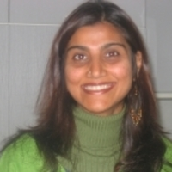 | 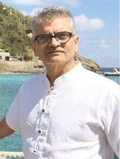
Asonzeh Ukah – HOD & Chair of Religious Studies  (Prof)  asonzeh.ukah@uct.ac.za  021 650 3761 | Sa’diyya Shaikh  (A/Prof)  sadiyya.shaikh@uct.ac.za  021 650 3462 | Abdulkader Tayob  (Prof)  abdulkader.tayob@uct.ac.za  021 650 3399
Christianity in Africa, African Religions  Asonzeh Ukah is the current Head of department. His areas of interests are in religion and globalisation; transnational religion; media and material culture of Pentecostalism; Pentecostal advertising: faith and films; urbanism and sacred space. | Islamic Studies, Feminist Theory  Sa'diyya Shaikh specializes in the area of Islamic Studies with a focus on gender, feminism and Islamic mysticism. Her research interests include theoretical developments in Islamic feminism, critical scholarship on gender violence and religion, and feminist readings of pre-modern Islamic texts, with a particular interest in the writings of the Sufi thinker Ibn Arabi. She has also published empirically-based research papers on South African Muslim women on issues relating to marriage, sexuality and gender relations. | Islamic Studies, Religion and Public Life  Abdulkader Tayob holds the NRF chair in Islam, African Publics and Religious Values. He is an internationally recognized scholar in the study of modern Islam in general, and Islam in Africa in particular. His research focus has been on Islamic revival, religious institutions and modern intellectual trends. He has carried out his research in South Africa, and in classical and modern textual traditions. Currently he is also focussing on East Africa and Egypt, examining biographical self-reflections of Islamists and other religious leaders. Prof. Tayob has a number of PG student scholarships available with his NRF chair.
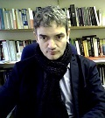 | 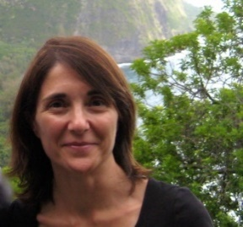 | 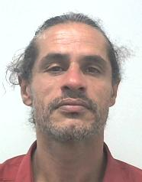
Louis Blond – PG Convener  (Dr)  louis.blond@uct.ac.za  021 650 3455 | Elisabetta Porcu – UG Convener  (A/Prof)  elisabetta.porcu@uct.ac.za  021 650 3993 | Ala Alhourani  (Dr)  ala.alhourani@uct.ac.za  021 650 3452
Jewish Thought  Louis Blond focuses on meaning in contemporary philosophy and philosophy’s relationship with politics, critical theory and religious discourse, particularly Jewish Thought. Previously he has explored responses to nihilism and homelessness in the work of thinkers such Franz Rosenzweig, Emmanuel Levinas and Martin Heidegger. His current research includes a re-examination of the philosophical descriptions of otherness, devekut, and the relationship between natural law and religion and politics. | Asian Religions, Japanese Religions, Religion and Society  Elisabetta Porcu specializes in Japanese Religions in contemporary society. Her research interests include Buddhism; religion, popular culture (manga and anime), media and consumerism; orientalism; secularization; religious festivals; as well as Japanese religions in South Africa. She has conducted extensive fieldwork in Japan where she has lived and worked for seven years. In her work she combines theoretical concepts with empirical research. | Islam, Religion and Ethics  Dr Ala Alhourani holds a PhD in Anthropology from the University of the Western Cape. His research interests include: Islam in Africa; aesthetic of religion and sensory culture; the public life of religion and ordinary ethics; performances and art, research methodology and visual ethnography.
Emeritus Professors
 | 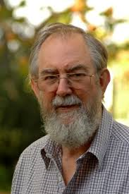 |  | 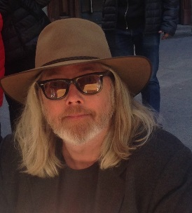
Charles A. Wanamaker  (Emeritus A/Prof)  chuck.wanamaker@uct.ac.za | John De Gruchy  (Emeritus Prof)  john@degruchy.co.za | Jim Cochrane  (Emeritus Prof)  jim.cochrane@uct.ac.za | David Chidester  (Emeritus Prof)  david.chidester@uct.ac.za

Honorary Research Associates Honorary Professor
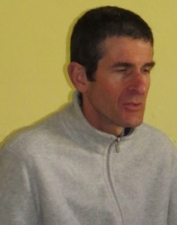 | 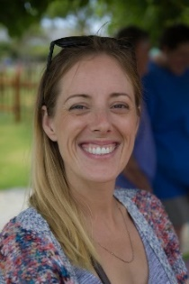
Frank England  (Dr)  Frank.England@uct.ac.za | Stephanie Smith  (Dr)  stephanie.smith.sa@gmail.com
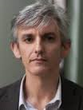
Ugo Dessi
(Dr)
Ugo.Dessi@uct.ac.za

Postdoctoral Fellows
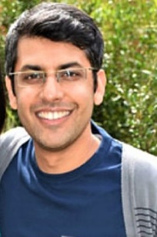
Nadeem Mahomed
(Dr)
nmahomed@gmail.com

Admin Staff
 | 
Tasneem Wise  (Mrs)  Administrative Assistant  tasneem.wise@uct.ac.za  021 6505818 | Jackie Stoffels  (Mrs)  Snr Secretary  jackie.stoffels@uct.ac.za  021 6503452
All departmental postgraduate administration | All departmental undergraduate administration
Research Institutes

The Research Institute on Christianity and Society in Africa (RICSA)

Centre for Contemporary Islam (CCI)
- SARChI Research Chair - Islam, African Publics and Religious Values
- The Center for the Study of Asian Religions (CSAR)

Librarian

Ms Ingrid Thomson
Librarian

Tel: 0216503133
Email:
Ingrid.Thomson@uct.ac.za
Ingrid is the librarian with the Humanities Information Division at UCT's main Chancellor Oppenheimer Library.

Postgraduate Faculty Staff

Mrs Sashni Chetty  ​ Faculty Manager  Beattie Building  Tel: 021 021650 4215  Email:  sashni.chetty@uct.ac.za | Ncumisa Mdingi-Nunu  Administrative Officer  Room 110, Beattie Building  Postgraduate Studies  Tel: 021 650 2692  Email:  ncumisa.mdingi-nunu@uct.ac.za  hum-postgrad@uct.ac.za | Charlton Esterhuizen  Administrative Officer  Room 110, Beattie Building  Postgraduate Studies  Tel: 021 650 5411  Email:  ce.esterhuizen@uct.ac.za  hum-postgrad@uct.ac.za | Mrs Debby Chuter  ​ Deputy Faculty Manager  Beattie Building  Tel: 0216501569  Email:  debby.chuter@uct.ac.za
Sashni is the Faculty Manager for both the Undergraduate and Postgraduate Offices. | Ncumisa and Charlton assist with all the following matters related to Honours, Masters and PhD programmes:  - admissions queries,  - registration,  - curriculum and CRS - checks and updates,  - LOA,  - concessions,  - record updates,  - examination of both Masters and PhD students,  - changes of marks and progression codes,  - graduation preparation including prelim FEC. |  | Debby is the Deputy Faculty Manager for both the Undergraduate and Postgraduate Offices.
Communicating with You
- Website
Please bookmark the postgrad notices page and check regularly:
http://www.religion.uct.ac.za/religion/postgraduates/postgraduatestudies/overview
- Vula
Vula is the UCT intranet and our main form of communication with you. Please ensure that you have access to it and check it regularly. www.vula.uct.ac.za
We have set up various Vula sites (internal web resource pages for registered students) for postgrad courses. Please note that you will be automatically added to the Vula course sites upon registration for the courses. We do however have a VULA Postgrad student site. Please see Tasneem Wise (LS5.36) to be added to this site. Vula is accessed here:
https://vula.uct.ac.za/portal
- Email and general contact details
Tasneem’s main form of communication with students is via her email distribution lists. Make sure she always has your latest details!
All students are assigned a UCT email address. It is studentnumber@myuct.ac.za (eg. smtjoe001@myuct.ac.za). When accessing your mail, go to the main UCT website and look for “myuct” in the quicklinks drop-down menu. Login using just your student number (eg. mrcjoa001) and your assigned password.
Be aware – if you forward your Vula notifications to a gmail or other account, this does not mean your UCT email is also going there! You should still check your myUCT email regularly for non-Vula mail.
- IT assistance / getting linked to the wi-fi network
See www.icts.uct.ac.za and the “student computing” link for all computer-related matters and assistance, including how to access the UCT wi-fi network. Their front office is in Room 2.01, Computer Sci building.
*** Forgotten your password? Go to: www.password.uct.ac.za ***
- Photos
Please send Tasneem a .jpeg picture of yourself. It helps her (and staff) to identify students, so you are not just a faceless name and student number!
- Noticeboard
Hardcopy notices are placed on the noticeboard outside Tasneem’s office (Rm5.36.)
- Consultation
All staff have consultation hours. Please contact staff on email. Tasneem is also available to assist you.

- UCT in general (PeopleSoft)
UCT requires that you keep all personal details current on the central database. Our student administration software is called “PeopleSoft” – also sometimes referred to as “Student Self Service”. It contains the official records and details of your studies here.
It is important that you keep your personal details up-to-date on PeopleSoft. If these are not current, you will miss vital information such as Fee accounts and even your graduation certificates if you elect to have them sent to you rather than attending graduation.

If you are encountering problems which are affecting your studies we encourage you to communicate with us sooner rather than later – we are here to assist in whatever way we can.
Solving Problems
Complaints
Ideally, you should try and communicate any dissatisfaction with the person directly concerned, but if you feel awkward or anxious about this, these are the steps you should take:
- About Courses:
  - discuss with your lecturers or administrator, if not resolved
  - escalate to programme convenor, who may then refer you to the Head of Dept.
- About Staff members: discuss with the Head of Department.
- About General Admin: discuss with Tasneem Wise, who may refer you to the Lecturer, Programme Convenor or Head of Dept.
Extensions
If anything impacts on your ability to complete an assignment, please communicate with your convenor. If medical, please produce a medical certificate when you submit. If the submission is beyond the UCT marks deadline, you need to apply for a formal extension for the course via the faculty. NB. For Honours, see “Honours – problems with completing” below.
Leave of Absence (LOA)
If you are experiencing problems which may affect the continuance of your studies - be they physical, emotional, or financial - you have recourse to applying for a leave of absence. This is an official sanctioned suspension of your studies, during which you remain on the books as a registered student, but effectively inactive until you resume your studies. Your LOA may be for a few weeks, it may be for a semester, it may be for a year. The period is dependent on when you think you are able to return (and, of course, whether it receives formal approval).
Applying for Leave of Absence needs to be done officially via the faculty. Speaking to your convenor will not activate this. The responsibility rests with you. You need to:
- Speak with your convenor and alert him/her about your intention to request a LOA;
- Complete the necessary paperwork and follow the procedure outlined below:
Forms Required: these forms can be downloaded available on the Administrative Forms website
- ACA037
- ACA038
- Attach the following supporting documents:
  - Supporting medical letter from doctor
  - Letter of motivation explaining the need for the LOA
  - Letter of support from the Department HOD

PROCESS | Responsible | CHECK

Application for Leave of Absence
This procedure is followed when a student wishes to take a leave of absence from the University and is usually done on medical grounds. At times students are advised to do this by their lecturers/supervisors if their personal/medical circumstances are disadvantaging their studies and process at UCT.
Student completes the ACA37/38 form which is available on the Administrative Forms website. | Student
Student uploads the completed form via their PeopleSoft self-service account. | Student
Once submitted this form triggers an alert to the Faculty manager that an application awaits.
The Faculty Manager reviews the application and either approves, denies or asks for more information. This is done within 1 working day of receiving the request and the student receives an alert. | Faculty Manager
The Faculty Manager forwards an approved LOA to the faculty administrator who captures the decision on PeopleSoft within 1 working day. | Faculty Manager
Honours – problems with completing

  - Courses
All courses should be completed within the stipulated 2 semester time-frame and finalised within the official UCT marks deadlines. Any request for an extension must be of an urgent and highly mitigating nature and, if granted, you will be required to re-register, pay for, and re-do the course in the next semester, unless you have applied for an official leave of absence.
Requests need to be addressed in writing to the Dean and submitted to the PG Faculty Office, after which they will go through the same process of approval as for the LOA above.
  - Research Project
Again, the faculty is reluctant to allow for extensions for the project. It is possible –but again, ONLY if an extremely valid reason is furnished. Here, they will allow for the project to be handed in before the resumption of the next semester without your having to register again or pay – IF the Dean has approved your request. But it must be before the semester start date. Requests need to be addressed in writing to the Dean and submitted to the PG Faculty Office, after which it will go through the same process of approval as for the LOA above.
Note: please check any faculty-related rules with the faculty – this is intended as a guideline and regulations may have changed.
Submission of Assignments
Submissions: electronic and hard copies
Physically Distanced Learning (PDL)
If the mode of teaching/learning for your course is online, all assignments and essays should be submitted electronically. You should submit 2 copies, one via email to your lecturer and the other should be uploaded to the relevant Vula course site.
Contact Learning (Face-to-Face)
If the mode of teaching/learning is face-to-face, both hardcopy and electronic assignments must be submitted. A hard copy can be submitted directly to your lecturer and an electronic copy should be uploaded to the relevant Vula course site.
Honours Projects (REL4011H)
For the Honours project, the soft copies need to submitted via the Vula course site (REL4011H) and a second copy needs to be emailed to your Honours Advisor and the PG Administrator, Ms Tasneem Wise (Tasneem.Wise@uct.ac.za)
In the event of loss of your assignment hardcopy
We expect you to keep copies (hardcopy or electronic) of all your assignments as a back-up in the event that an assignment gets lost for whatever reason. Such assignments will only be marked if proof of earlier receipt is furnished.
Lost data / stolen hardware / corrupted data…
Please take contingency measures against lost or corrupted data:
- Back-up assignments separate from your home PC or laptop (on disc or flash drive or hardcopy). Do not carry them both together!
- Do not store data on flash drives only (send it to yourself via email if you are working in a lab – and then back it up on your home computer, another flash drive, or keep a hardcopy)
- Keep saving when working (hitting “Ctrl” and “S” on your keyboard is a quick way!). SA is prone to blackouts – don’t get caught out!
If adequate steps have not been taken to ensure the safety of your data, staff are not obliged to accept requests for late submissions.
Assignment coversheet
All submissions need to have the departmental cover page attached. Downloadable from the PG vula site under “resources” or in your course sites on Vula. (see attached page 38)

The Honours Research Project
The Honours programme takes 1 year.
All students are required to complete 4 taught courses and a research essay (15000-word dissertation).
Lectures
Contact Learning (Face-to-Face)
If we follow a contact learning mode of teaching…
  - All PG lectures take place on Wednesday’s at the allotted times in the Religious Studies Seminar Room, except for the Critical Terms in Religious Studies 1 and Islamic Studies courses which takes place in block sessions (see pages 42 & 43 below for lecture dates & times)
Physically Distanced Learning (PDL)
If we follow an online mode of teaching….
  - All PG lectures will take place online via Zoom or Microsoft Teams. Your lecturers will liaise with you in this regard.
Attendance is compulsory. Your lectures are intended to give you all of the necessary information needed to get you started with, and guide you in, conducting your research.
*****For lecture times, venue & mode of teaching please see pages 42 & 43 below
Seminars
Contact Learning (Face-to-Face)
If we follow a contact learning mode of teaching…
  - The Department offers weekly seminars that take place on Wednesdays from 1-2pm, in the Religious Studies Seminar Room.
  - These seminars are presented by staff and/or visiting guests on various topics
Physically Distanced Learning (PDL)
If we follow an online mode of teaching….
- Due to Covid-19 there will be no seminars until we return to campus and it is deemed safe to commence with offering events & contact learning
Advisors
Finding an Advisor:
- The Research Project is self-led research. Advisors do not function as full supervisors (as in Masters/PhD).

- Students should consult with a prospective advisor with expertise in their proposed research topic/area.

- Your programme convenor (Dr Louis Blond - room 5.45) will be able to advise you on who best to approach.

- Honours students should secure an advisor as early as possible (we recommend that your topic and advisor be finalised by April).

- Once your advisor is confirmed, you need to send an email to the PG Administrator (Mrs Tasneem Wise Tasneem.Wise@uct.ac.za) to confirm your advisors details and provisional research title.

What to expect from your Advisor:

- Students are entitled to at least three consultations with their advisor
  - At the start of the year for topic-specific guidance and advice (around April).
  - Mid-way through the year for specific guidance and advice on a 1st draft of your thesis (around August)
  - At the end of the year to review and advise on your thesis prior to final submission (around early October)

- Advisors are not required to fill in any gaps of knowledge in the event you did not attend the lecture.

What your Advisor expects from you:

- It is very important to note that it is YOUR ROLE as the student to initiate contact with your advisor and to request the necessary meetings you require in order to meet the obligations for your Honours thesis
- Maintain regular contact with your advisor
- You should have a clear programme of action. Together with your advisor you should set and agree on necessary deadlines that need to be met throughout the year
- You should provide regular delivery of work based on the programme of action agreed upon
- You need to work hard and remain committed to the research project
- Be responsive and remain open to taking advice from your academic advisor
Navigating the thesis
- Decide on a research topic
- Secure an advisor
- You should have a clear programme of action. Together with your advisor you should set and agree on necessary deadlines that need to be met throughout the year
- Proposed research topic should be finalised by end May and communicated to Mrs Tasneem Wise together with the name of your advisor
- If your research involves interactions with human subjects, it is important that you get ethics clearance prior to starting your research (contact Tasneem Wise for requirements)
- You should maintain regular contact with your advisor
- You should be ready to submit a first draft to your advisor by August
- You should be ready to submit a final draft to your advisor by early October
- Final thesis should be submitted to the Department for examination by 05 November 2021
Research Ethics
If your research involves interaction with other human beings as part of the research process (including interviews, filling out of questionnaires or focus groups with “human subjects”) it is important that you get ethics clearance prior to starting your research. Please see the Department website for the ethics procedure details or alternatively speak to Tasneem Wise.
*** (see attached Ethics Process Flow page 41)
Submission
- The hand-in date is 05 November 2021
- The limit is 15,000 words
- Submission Requirements:
- One soft copy on Vula (uploaded to the assignment tab of the REL4011H course site)
- One soft copy (emailed to advisor and Tasneem Wise)
- One hard copy (given to your advisor)
*** (see attached Honours Submission Checklist page 30 and Postgraduate Programmes page 37)
Marking
Marking is done by one internal marker and one external examiner.
Grades:
Your final grade will be posted on the Departmental notice board by noon on 09 December 2021 end and will be available on PeopleSoft on 22 December @ 16:00pm.

The Masters Programme
The department offers two types of Masters Degrees.
- A Masters by coursework (REL5003W) takes two years. Students take four courses at 5000level (you may take an elective in another Department) and write a 25,000 word dissertation.
- A Masters by research (REL5000W) does not involve coursework. Students write a substantial 50,000 word dissertation
Lectures (Coursework Masters only)
Contact Learning (Face-to-Face)
If we follow a contact learning mode of teaching…
  - All PG lectures take place on Wednesday’s at the allotted times in the Religious Studies Seminar Room, except for the Critical Terms in Religious Studies 1 and Islamic Studies courses which takes place in block sessions (see pages 42 & 43 below for lecture dates & times)
Physically Distanced Learning (PDL)
If we follow an online mode of teaching….
  - All PG lectures will take place online via Zoom or Microsoft Teams. Your lecturers will liaise with you in this regard.
Attendance is compulsory. Your lectures are intended to give you all of the necessary information needed to get you started with, and guide you in, conducting your research.
*****For lecture times, venue & mode of teaching please see pages 42 & 43 below
Seminars
Contact Learning (Face-to-Face)
If we follow a contact learning mode of teaching…
  - The Department offers weekly seminars that take place on Wednesdays from 1-2pm, in the Religious Studies Seminar Room.
  - These seminars are presented by staff and/or visiting guests on various topics
Physically Distanced Learning (PDL)
If we follow an online mode of teaching….
- Due to Covid-19 there will be no seminars until we return to campus and it is deemed safe to commence with offering events & contact learning

Registration

Coursework Masters

- In year 1 of your Coursework Masters you register for your 4 taught courses only.

- In year 2 of your Coursework Masters you will register for your Dissertation component (REL5003W)

- You must submit your thesis proposal 3 months from the date of your registration of the thesis component.

- You will need the following to register:
- Registration Form
- Curriculum form (to add the course code)
- Memo of Understanding form (this form is completed online via the PeopleSoft system. This form must be filled in together with your supervisor and must be submitted online prior to registering for the thesis. This formalises expectations for supervision on the part of both supervisor and student. Returning Masters Students fill in a shorter, addendum to the form (PPA form) and this is also done online via the PeopleSoft system.

NB! If you are planning on completing both coursework and thesis in one year – i.e. before the official start of the next academic year – be sure to submit your proposal and register before the course addition cut-off date for the year!! (see faculty website)

Research Masters

- For research masters you will register for your Dissertation component (REL5000W)

- You must submit your thesis proposal 3 months from the date of your first registration.

- You will need the following to register:
- Registration Form
- Curriculum form (to add the course code)
- Memo of Understanding form (this form is completed online via the PeopleSoft system. This form must be filled in together with your supervisor and must be submitted online prior to registering for the thesis. This formalises expectations for supervision on the part of both supervisor and student. Returning Masters Students fill in a PPA form, which is the assessment of your progress as well as you amended agreement/expectations for the year-end, and this is also done online via the PeopleSoft system.

Supervision
At the heart of the postgraduate experience is a more intensive relationship with a researcher who is your appointed supervisor, whether for your Masters dissertation, or the capstone PhD work. You are entitled to expect a steady level of support from your supervisor; s/he in turn is entitled to expect a specific level of application from you. These expectations are recorded in a Memorandum of Understanding or an annual supplement between the student and supervisor.
As postgraduate work becomes more independent, and the onus falls more and more on the researcher, the Department is committed to ensuring that your relationship with your supervisor and the department is as productive as possible.

Students should consult with prospective supervisors who have expertise in their proposed topic. Your programme convenor (Dr Louis Blond – room 5.45) will be able to advise you on who best to approach.
Finding a Supervisor:
Choosing a supervisor for your postgraduate research is probably not the most important decision you will make in your life. Choosing a supervisor, however, is no light-weight matter. Even though such choice may be constrained by your research interests or by the people available in a particular department to work with, it is critical to spend some time dreaming and planning. In your ideal world, with whom would you like to work as a young researcher and writer? In this ideal world, what kind of relationship would suit you best? What does your own experience, to date, tell you about the kinds of evaluation, support, and feedback from teachers that work well for you?
Broadly speaking, there are three main areas in which it is useful to try and assess someone's skills if you want to work with them as a postgraduate research student.
- Do they have a solid sense of the academic conventions and guidelines through which a research project can be transformed into a "Masters" or "Doctoral" dissertation?
- Do they have intellectual standing as researchers and writers within the specific discipline, and research field, in which you want to work?
- Does their communicative and pedagogic style suit you?
The way to find some answers to these questions is to engage in some research of your own.
- Use the internet, or other sources, to find and read material authored by people you might want to work with.
- Speak with other young researchers about their experiences of working with particular supervisors (each person is different, so you will need to take such information on board with care).
- Attend a prospective supervisor's seminars, or lectures; while this does not say everything about their communicative style, it will give you a hint of their approach to pedagogy (do they appear to respect their students? is there evidence that they prepare inputs with thought? do they use contemporary research to support arguments made in lecture space? are they flexible when it comes to hearing others' ideas?).
- Arrange to meet a prospective supervisor, and talk with them about your ideas, experiences, and hopes. Ask them about their own supervision style.
- Read dissertations written by students with whom they have worked.
- Find out how accessible they are (do they have a reputation for missing appointments, being extremely busy, not handing back marked material timeously?)
In other words, take the choice seriously and simultaneously allow for the reality that even with careful planning, the real potential of a good supervisory relationship cannot always be predicted.
Good supervisory relationships can last into a lifetime of collegial friendship, and support; poor ones cause sleepless nights and confused days. We do our best to support you in the process of making a choice that will work for you.
- Students should consult with a prospective advisor with expertise in their proposed research topic/area.

- Your programme convenor (Dr Louis Blond - room 5.45) will be able to advise you on who best to approach.

- Masters students should secure an advisor as early as possible (we recommend that your topic and supervisor be finalised by March).

- Once your supervisor is confirmed, you need to send an email to the PG Administrator (Mrs Tasneem Wise Tasneem.Wise@uct.ac.za) to confirm your advisors details and provisional research title.

What to expect from your Supervisor:
What can you expect of your supervisor?
- Your supervisor will meet you regularly to discuss your progress with your research project and to comment on the material you have submitted.
- Your supervisor will provide you with support and advice, drawn from the supervisor's experience and expertise.
- Research projects are lengthy and demanding commitment, and you will need the general support of your supervisor (and your friends and family).
- Your supervisor will provide timeous feedback on your written submissions, with constructive criticism.
- In addition, your supervisor will provide regular contact, guidance, encouragement and feedback

What your Supervisor expects from you:
What can your supervisor expect of you?
*The supervisor will expect: regular contact, hard work and commitment as well as responsiveness and openness to advice from you.
- It is very important to note that it is YOUR ROLE as the student to initiate contact with your advisor and to request the necessary meetings you require in order to meet the obligations for your Master’s thesis
- Maintain regular contact with your supervisor. You need to take the initiative in seeking regular contact with your supervisor. Your obligation is to keep closely in touch.
- You should have a clear programme of action. Together with your advisor you should set and agree on necessary deadlines that need to be met throughout the year
- You should provide regular delivery of work based on the programme of action agreed upon
- You need to work hard and remain committed to the research project
- Be responsive and remain open to taking advice from your academic advisor. You need to respond positively to the constructive criticism of your supervisor, and incorporate this into your work.

For more information, see guidelines for the appointment of supervisors of Doctoral candidates and responsibilities of supervisors of Masters and Doctoral candidates.

Guidelines: http://www.humanities.uct.ac.za/downloads/humanities/postgrad/gradschool/navthesis/supervise/mou.pdf)

Responsibilities: http://www.humanities.uct.ac.za/downloads/humanities/postgrad/gradschool/navthesis/supervise/responsibilities.pdf
Research Ethics
If your research involves interaction with other human beings as part of the research process (including interviews, filling out of questionnaires or focus groups with “human subjects”) it is important that you get ethics clearance. Please contact Tasneem Wise (Tasneem.Wise@uct.ac.za) with subject “Ethics Clearance” to obtain requirements and forms.
*** (see attached Ethics Process Flow page 41)

Proposal Presentations
Due to Covid-19 all Presentations for 2021 may be cancelled – the department will send communication via email in this regard.

Masters and PhD students are required to make formal presentations of their dissertation proposals to the Department. These are co-ordinated by Dr Louis Blond and Tasneem Wise. Presentations are held in May and October, during which staff will be present to give feedback. These are vital feedback sessions that must be attended, as well as supported by fellow students. Further details regarding these sessions and its requirements will be sent out via email closer to the time

Objective of the PG Presentation

- On this day all post-graduate students (Masters by coursework, research Masters and PhDs) are required to present a piece of their work to a wider audience as a means of tracking progress.
- This is an opportunity to share ideas with colleagues and faculty staff and to receive feedback on aspects of your work from staff members and fellow PG students.
- Presenting at this event provides an exceptionally useful opportunity for:
  - training oneself in presentation skills;
  - re-thinking aspects of one's work based on constructive comments received;
  - gaining new insights and inspiration from listening to the presentation of fellow students who are working on topics that are often only apparently distant to one's own.
Obligations of PG students:
- All Masters, Research Masters and PhD students who plan to submit their thesis at the end of the year and early the next year MUST present at one of the sessions each year.
- Students who are already in the process of writing their theses can either present a draft chapter of the thesis OR some reflections on theoretical and methodological issues they have been thinking upon during their work
- Students who have just started should present their research proposals.
- Non-research students (Masters by Coursework) are also warmly encouraged to grab this opportunity to present their research in the form of a Poster (including title, research questions and a few lines about the theoretical framework) which will be exposed in the Department. This would be an excellent way to showcase your work in the Department and receive feedback from senior students and staff.
- Research Masters and PhD’s to present each year as a way to keep track of their progress
- Students should share copies of presentations or papers prior to the day that will be circulated among staff and fellow students
Presenting at this event:
- You will be allocated at least 45minutes (30 mins + 15 mins feedback/discussion)
- A laptop and speakers will be set up for you to utilise, so please bring your presentations along on a flash OR you may bring your own laptop along
- Please remember to send a copy of your presentation or paper at least 5 days prior to the event so that this can be circulated to all staff and fellow students
Submission Procedures
Presentation and submission of a master’s dissertation
- Master’s candidates are to submit electronic versions of (full or minor) dissertations/theses online via the PeopleSoft Student Administration Self-service functionality. Hard copies of ‘intention to submit’ forms and dissertations/theses no longer need to be physically deposited; you must submit your work for examination from any digitally- connected destination.
- At the conclusion of your research, you will be required to complete and upload your ‘intention to submit’ form on PeopleSoft, followed by the upload of your dissertation/thesis. All communication from UCT regarding the examination process will occur via your UCT e-mail address – [student number]@myuct.ac.za.
- Please make sure that you have your username and password and are able to access the PeopleSoft Student Administration Self Service.
- Should you have any problems with this service, please consult the following document: Accessing PeopleSoft Self Service for Students, or get help by accessing Student Self Service Help or emailing sss-helpdesk@uct.ac.za.
Submit your thesis as required:
Candidates are required to give written notice of intention to submit at least 5 months before the deadline for qualification entry (See GM16 and GP5.3) in advance of submitting your thesis. Once you submit your notice of intention to submit, the Postgraduate Office starts the process of appointing external examiners, so that there will be no delay once you submit your thesis.
Submit your thesis as required by
Deadlines for December graduation Deadlines for April graduation
Beginning of June | Submission of dissertation/thesis (to have been preceded by the intention to submit) at least 5 months before the deadline for qualification entry). See GM16 and GP5.3 | 1 September of previous year | Submission of dissertation/thesis (to have been preceded by the intention to submit) at least 5 months before the deadline for qualification entry. See GM16 and GP5.3
31 October | Final date for qualifier status to be on system. See Senate approved academic calendar | 1 February | Final date for qualifier status to be on system, after Faculty Examination Committees have met

*Please see attached: UCT Digital upload of dissertations FULL GUIDE for submission instructions

Examination Procedures
- Once you submit your notice of intention to submit, the Humanities Postgraduate Office starts the process of appointing external examiners, so that there will be no delay once you submit your thesis. If you do not notify the Postgraduate Office of your intention to submit, examiners will not have been appointed in advance and the examination of your thesis may be delayed. (Do not notify the Faculty's Postgraduate Office of your intention to submit if you are not ready - if examiners are appointed and you do not submit, it becomes difficult to find examiners again when you submit later.
- The Faculty's Postgraduate Office sends a copy to each examiner. Examiners are expected to return their reports in 6 weeks. If the examiner has not done so by week 6, the Postgraduate Office administrator(s) will follow up. The Faculty's Postgraduate Office does not undertake to reach a decision by any specific date.
- Within 48 hours of receiving the examiners' reports, the Faculty's Postgraduate Office administrators sends these to the department which has 5 days to respond and to produce a consolidated report. Once the department has responded by submitting the consolidated report, your reports are put to the Masters Dissertation Examination Committee (MDEC).
- The MDEC will be convened to decide the results a week thereafter. Once the results are known, you will be informed.
  - If no corrections are required, the result is entered on system.
  - If minor corrections are required, your supervisor oversees these and informs the Faculty's Postgraduate Office when these are satisfactorily done so that the result can be entered.
- Overall processing time from date of submission is 9 weeks (longer if notice of intention to submit was not given).
*** (see attached Masters Submission Checklist page 31 and Postgraduate Programmes page 37)

The PhD Programme
PhD by research: (REL6000w)
All students are required to complete a dissertation (80 000 words)
The PhD is by dissertation only, and involves original research. The thesis should be in the region of 80,000 words and takes at least 3 years to complete.
Seminars
Contact Learning (Face-to-Face)
If we follow a contact learning mode of teaching…
  - The Department offers weekly seminars that take place on Wednesdays from 1-2pm, in the Religious Studies Seminar Room.
  - These seminars are presented by staff and/or visiting guests on various topics
Physically Distanced Learning (PDL)
If we follow an online mode of teaching….
- Due to Covid-19 there will be no seminars until we return to campus and it is deemed safe to commence with offering events & contact learning

Registration

- For PhD you will register for your Dissertation component (REL6000W)

- You must submit your thesis proposal 6 months from the date of your first registration.

- You will need the following to register:
- Registration Form
- Curriculum form (to add the course code)
- Memo of Understanding form (this form is completed online via the PeopleSoft system. This form must be filled in together with your supervisor and must be submitted online prior to registering for the thesis. This formalises expectations for supervision on the part of both supervisor and student. Returning PhD Students fill in a PPA form, which is the assessment of your progress as well as you amended agreement/expectations for the year-end, and this is also done online via the PeopleSoft system.

Supervision
At the heart of the postgraduate experience is a more intensive relationship with a researcher who is your appointed supervisor, whether for your Masters dissertation, or the capstone PhD work. You are entitled to expect a steady level of support from your supervisor; s/he in turn is entitled to expect a specific level of application from you. These expectations are recorded in a Memorandum of Understanding or an annual supplement between the student and supervisor.
As postgraduate work becomes more independent, and the onus falls more and more on the researcher, the Department is committed to ensuring that your relationship with your supervisor and the department is as productive as possible.

Students should consult with prospective supervisors who have expertise in their proposed topic. Your programme convenor (Dr Louis Blond – room 5.45) will be able to advise you on who best to approach.

Finding a Supervisor:
Choosing a supervisor for your postgraduate research is probably not the most important decision you will make in your life. Choosing a supervisor, however, is no light-weight matter. Even though such choice may be constrained by your research interests or by the people available in a particular department to work with, it is critical to spend some time dreaming and planning. In your ideal world, with whom would you like to work as a young researcher and writer? In this ideal world, what kind of relationship would suit you best? What does your own experience, to date, tell you about the kinds of evaluation, support, and feedback from teachers that work well for you?
Broadly speaking, there are three main areas in which it is useful to try and assess someone's skills if you want to work with them as a postgraduate research student.
- Do they have a solid sense of the academic conventions and guidelines through which a research project can be transformed into a "Masters" or "Doctoral" dissertation?
- Do they have intellectual standing as researchers and writers within the specific discipline, and research field, in which you want to work?
- Does their communicative and pedagogic style suit you?
The way to find some answers to these questions is to engage in some research of your own.
- Use the internet, or other sources, to find and read material authored by people you might want to work with.
- Speak with other young researchers about their experiences of working with particular supervisors (each person is different, so you will need to take such information on board with care).
- Attend a prospective supervisor's seminars, or lectures; while this does not say everything about their communicative style, it will give you a hint of their approach to pedagogy (do they appear to respect their students? is there evidence that they prepare inputs with thought? do they use contemporary research to support arguments made in lecture space? are they flexible when it comes to hearing others' ideas?).
- Arrange to meet a prospective supervisor, and talk with them about your ideas, experiences, and hopes. Ask them about their own supervision style.
- Read dissertations written by students with whom they have worked.
- Find out how accessible they are (do they have a reputation for missing appointments, being extremely busy, not handing back marked material timeously?)
In other words, take the choice seriously and simultaneously allow for the reality that even with careful planning, the real potential of a good supervisory relationship cannot always be predicted.
Good supervisory relationships can last into a lifetime of collegial friendship, and support; poor ones cause sleepless nights and confused days. We do our best to support you in the process of making a choice that will work for you.
- Students should consult with a prospective advisor with expertise in their proposed research topic/area.

- Your programme convenor (Dr Louis Blond - room 5.45) will be able to advise you on who best to approach.

- PhD students should secure an advisor as early as possible (we recommend that your topic and supervisor be finalised at least 1 month from date of registration).

- Once your supervisor is confirmed, you need to send an email to the PG Administrator (Mrs Tasneem Wise Tasneem.Wise@uct.ac.za) to confirm your advisors details and provisional research title.

What to expect from your Supervisor:
What can you expect of your supervisor?
- Your supervisor will meet you regularly to discuss your progress with your research project and to comment on the material you have submitted.
- Your supervisor will provide you with support and advice, drawn from the supervisor's experience and expertise.
- Research projects are lengthy and demanding commitment, and you will need the general support of your supervisor (and your friends and family).
- Your supervisor will provide timeous feedback on your written submissions, with constructive criticism.
- In addition, your supervisor will provide regular contact, guidance, encouragement and feedback

What your Supervisor expects from you:
What can your supervisor expect of you?
*The supervisor will expect: regular contact, hard work and commitment as well as responsiveness and openness to advice from you.
- It is very important to note that it is YOUR ROLE as the student to initiate contact with your advisor and to request the necessary meetings you require in order to meet the obligations for your Master’s thesis
- Maintain regular contact with your supervisor. You need to take the initiative in seeking regular contact with your supervisor. Your obligation is to keep closely in touch.
- You should have a clear programme of action. Together with your advisor you should set and agree on necessary deadlines that need to be met throughout the year
- You should provide regular delivery of work based on the programme of action agreed upon
- You need to work hard and remain committed to the research project
- Be responsive and remain open to taking advice from your academic advisor. You need to respond positively to the constructive criticism of your supervisor, and incorporate this into your work.

For more information, see guidelines for the appointment of supervisors of Doctoral candidates and responsibilities of supervisors of Masters and Doctoral candidates.

Guidelines: http://www.humanities.uct.ac.za/downloads/humanities/postgrad/gradschool/navthesis/supervise/mou.pdf)

Responsibilities: http://www.humanities.uct.ac.za/downloads/humanities/postgrad/gradschool/navthesis/supervise/responsibilities.pdf

Research Ethics
If your research involves interaction with other human beings as part of the research process (including interviews, filling out of questionnaires or focus groups with “human subjects”) it is important that you get ethics clearance. Please contact Tasneem Wise (Tasneem.Wise@uct.ac.za) with subject “Ethics Clearance” to obtain requirements and forms.
*** (see attached Ethics Process Flow page 41)

Proposal Presentations
Due to Covid-19 all Presentations for 2021 may be cancelled – the department will send communication via email in this regard.

Masters and PhD students are required to make formal presentations of their dissertation proposals to the Department. These are co-ordinated by Dr Louis Blond and Tasneem Wise. Presentations are held in May and October, during which staff will be present to give feedback. These are vital feedback sessions that must be attended, as well as supported by fellow students. Further details regarding these sessions and its requirements will be sent out via email closer to the time.
Objective of the PG Presentation

- On this day all post-graduate students (Masters by coursework, research Masters and PhDs) are required to present a piece of their work to a wider audience as a means of tracking progress.
- This is an opportunity to share ideas with colleagues and faculty staff and to receive feedback on aspects of your work from staff members and fellow PG students.
- Presenting at this event provides an exceptionally useful opportunity for:
  - training oneself in presentation skills;
  - re-thinking aspects of one's work based on constructive comments received;
  - gaining new insights and inspiration from listening to the presentation of fellow students who are working on topics that are often only apparently distant to one's own.
Obligations of PG students:
- All Masters, Research Masters and PhD students who plan to submit their thesis at the end of the year and early the next year MUST present at one of the sessions each year.
- Students who are already in the process of writing their theses can either present a draft chapter of the thesis OR some reflections on theoretical and methodological issues they have been thinking upon during their work
- Students who have just started should present their research proposals.
- Non-research students (Masters by Coursework) are also warmly encouraged to grab this opportunity to present their research in the form of a Poster (including title, research questions and a few lines about the theoretical framework) which will be exposed in the Department. This would be an excellent way to showcase your work in the Department and receive feedback from senior students and staff.
- Research Masters and PhD’s to present each year as a way to keep track of their progress
- Students should share copies of presentations or papers prior to the day that will be circulated among staff and fellow students
Presenting at this event:
- You will be allocated at least 45minutes (30 mins + 15 mins feedback/discussion)
- A laptop and speakers will be set up for you to utilise, so please bring your presentations along on a flash OR you may bring your own laptop along
- Please remember to send a copy of your presentation or paper at least 5 days prior to the event so that this can be circulated to all staff and fellow students
Submission Procedures

SUBMISSION OF a PhD thesis to the DDB OFFICE

It is expected that a PhD is completed in 4 years. After 5 years, PhD students may have a 50% late surcharge penalty applied.
Examination Procedures
- PhD candidates must upload their notice of intention to submit theses for examination on PeopleSoft at least 6 – 8 weeks before submission of their theses for examination.
- PhD candidates must upload their theses for examination on PeopleSoft at least 5 months before the upcoming graduation ceremony to allow time for the examination process to run its course.
*2021 Graduation Ceremonies are scheduled for April and December 2021
- A PhD Candidate can submit at any time subject to being registered for 2 years.
- While the DDB will not insist on the supervisor’s approval before accepting a PhD thesis, it is recommended that candidates submit with the approval of their supervisors.
- At the conclusion of your research, you will be able to complete and upload your intention to submit form on PeopleSoft, followed by the upload of your thesis for examination. All communication from UCT regarding the examination process will occur via your UCT e-mail account.
- Once you submit your notice of intention to submit, the DDO starts the process of calling for nomination of external examiners. If you do not notify the DDO of your intention to submit, examiners will not have been appointed in advance and the examination of your thesis will be delayed until examiners have been nominated and approved first by Faculty and then by the Doctoral Degrees Board.
- The DDO sends a copy to each of the three external examiners. Examiners are expected to return their reports in 8 weeks. If the examiner has not done so by week 8, the DDO will follow up.
- Once all three reports have been received by the DDO, they are forwarded to the Faculty and the Doctoral Committee of Assessors (comprising a core group of senior Faculty members, the supervisor and relevant HOD) who are required to study the reports and make a recommendation to the DDB. Once the DCOA recommendation has been approved by the DDB, the student is advised of the outcome by the DDO.
- The overall processing time is approximately 12 weeks from submission of the thesis.
*Please see attached: PhD Student Examination Guide for submission instructions
*** (see attached PhD Submission Checklist page 36 and Postgraduate Programmes page 37)

2021 Deadlines
***Available at time of press. (dates are subject to change)
Unless stipulated otherwise, all papers are due by 4pm on the due date in both hard copy and electronic format via email and on Vula. Some staff may elect to have submissions at class. Please establish this with the lecturer or check the course outline.
*Extensions will only be granted for medical reasons and a medical note would need to accompany the request.
SUBMISSION DATES FOR 2021
EVENT | DATE
Presentations: Postgrad Presentations – all students to present their draft research proposals (Honours and first-year Masters) or chapters of theses (for PhD or second year Masters)  Masters/PhD Presentation Day - all PhD and Research Masters students to present their draft research proposals | (Due to Covid-19 all presentations for 2021 may be cancelled) – the department will send communication via email in this regard.  Should we proceed with face-to-face or online presentations, the presentations will be scheduled as follows:  27 May 2021  28 October 2021
Finalisations:  All proposal topics to be finalised and supervisors to be confirmed by these times | Honours: May 2021  Masters: May 2021  PhD: 6 months from registration date (dependant on when you registered)
PG Masters & PhD Proposals Screening  All proposals to be submitted to supervisors for review at least 2 weeks before the proposals are due at the Faculty | Research Masters students are required to submit their final proposals to faculty office within three months after registration.  PhD students are required to submit their final proposals to faculty office within six months after registration.
Honours Dissertation – Final Draft | Anytime during October but no later than 15 October 2021  Please note that the earlier you submit your Final draft to your supervisor the better, as your Supervisor will need time to review, mark and provide you with feedback so that you can update and finalise your thesis for the 05th of November deadline
Honours Dissertation – Final Submission  An Honours degree should be completed in one year (full-time). | 05 November 2021 – Dissertation to be submitted to advisors for grading  12 November 2021 – Advisors to submit all dissertations and grades to Tasneem
Masters Dissertation  It is expected that a Masters is completed in one or two years. After 3 years, Masters students may have a 50% late surcharge penalty applied to your course fee. | Please consult the Faculty Office or Student Records for updated graduation details  The primary graduation season will fall in April, followed by a smaller session in December of the same year. This highlights the importance of adhering to closing dates, which will be enforced in all cases. Dissertation and thesis deadlines will be applied strictly as outlined below, with no exceptions made for late submissions.  Deadlines for December graduation  Deadlines for April graduation
  Beginning of June | Submission of dissertation/thesis (to have been preceded by the intention to submit) at least 5 months before the deadline for qualification entry). See GM16 and GP5.3
  31 October | Final date for qualifier status to be on system. See Senate approved academic calendar
  1 September of previous year | Submission of dissertation/thesis (to have been preceded by the intention to submit) at least 5 months before the deadline for qualification entry. See GM16 and GP5.3
  1 February | Final date for qualifier status to be on system, after Faculty Examination Committees have met
PhD Thesis  It is expected that a PhD is completed in 4 years. After 5 years, PhD students may have a 50% late surcharge penalty applied. | Deadline dates  PhD candidates must upload their notice of intention to submit theses for examination on PeopleSoft at least 6 – 8 weeks before submission of their theses for examination.  PhD candidates must upload their theses for examination on PeopleSoft at least 5 months before the upcoming graduation ceremony to allow time for the examination process to run its course.  2021 Graduation Ceremonies are scheduled for April and December 2021

2021 Course List
FIRST SEMESTER
COURSE CODE | DESCRIPTION | CONVENOR/LECTURER
REL4010F/REL5117F | Critical Terms in Religious Studies 1 | Prof Abdulkader Tayob
REL4110F/REL5110F | African Religious Movements | Prof Asonzeh Ukah
REL4113F/REL5113F | Issues in Contemporary Jewish Thought | Dr Louis Blond
REL4049F/REL5115F | Islamic Studies | Prof Abdulkader Tayob
REL5111F | Reading Religious Texts | A/Prof Elisabetta Porcu

SECOND SEMESTER

COURSE CODE | DESCRIPTION | CONVENOR/LECTURER
REL4012S/REL5118S | Critical Terms in Religious Studies 2 | A/Prof Sa’diyya Shaikh  A/Prof Elisabetta Porcu
REL4046S / REL5114S | Buddhism | A/Prof Elisabetta Porcu
REL4091S/REL5091S | Explorations in Islam | A/Prof Sa’diyya Shaikh
REL5111S | Reading Religious Texts | A/Prof Elisabetta Porcu

Full Year Courses (Research Essays/Thesis)

COURSE CODE | DESCRIPTION | CONVENOR/LECTURER
REL4011H | Honours Research Project | Dr Louis Blond
REL5000W | Research Masters | Dr Louis Blond
REL5003W | Coursework Masters | Dr Louis Blond
REL6000W | PhD | Dr Louis Blond

Emergency Numbers & Assistance

(all UCT numbers, except for Police)

Campus Protection Services
Burnage (Lower Campus) | …………………021 650 2222 / 3
Robert Leslie (Upper Campus) | ………………………..021 650 2121
Kramer (Middle Campus) | ………….021 650 3022 (nights) 5759 (day)
Health Sciences Campus | …..……..021 650 6100 / 6690
Hiddingh Campus | ………………………..021 480 7101
Forest Hill (Residence) | ………………………..021 650 3856
Liesbeeck Gardens (Residence) | ….021 650 3958 (reception)
Student Wellness Centre | ………….021 650 4589 / 3000
Discrimination & Harassment Office | ………………………..021 650 3530
Traffic Services | ………….021 650 3312 / 3 / 4
Access Control | ………….021 650 3996 / 3030
Police
Rondebosch | ………………………..021 689 9321
Mowbray | ………………………..021 685 7111
Woodstock | ………………………..021 442 3100

APPENDICES

Submission Checklists


CHECKLIST FOR DISSERTATION/THESIS SUBMISSIONS
Honours Dissertation
Candidates are required to submit a draft thesis to their Supervisor on an ongoing basis during the year. A final draft should be submitted to the Supervisor by no later than 15 October 2021 for review, after which necessary amendments can be made.
The Final thesis should be submitted to the Supervisor and Department’s Admin Assistant by 05 November 2021 for an April graduation. *Extensions will only be granted for medical reasons and a medical note would need to accompany the request.
The Department sends a copy of your thesis to internal and external examiners. Examiners are expected to return their reports within 1 week. External examiners may occasionally take longer. If the examiner has not submitted by two weeks, the Admin Assistant will follow up. All results need to be submitted to Faculty by December to ensure graduation during this academic year.
Dissertation should include the following:
2 soft copies
*one copy to be emailed to advisor and Tasneem.Wise@uct.ac.za
*one copy to be uploaded to the Vula site: REL4011H
Dissertation/Thesis cover page and Plagiarism Declaration
*this can be accessed on any of your REL Vula Course sites https://vula.uct.ac.za/portal or the Department website http://www.religion.uct.ac.za


CHECKLIST FOR DISSERTATION/THESIS SUBMISSIONS

Master’s Dissertation
Candidates are required to give written notice of intention to submit at least 5 months before the deadline for qualification entry (See GM16 and GP5.3) in advance of submitting your thesis. Once you submit your notice of intention to submit, the Postgraduate Office starts the process of appointing external examiners, so that there will be no delay once you submit your thesis.
Submit your thesis as required by
Deadlines for December graduation Deadlines for April graduation
Beginning of June | Submission of dissertation/thesis (to have been preceded by the intention to submit) at least 5 months before the deadline for qualification entry). See GM16 and GP5.3 | 1 September of previous year | Submission of dissertation/thesis (to have been preceded by the intention to submit) at least 5 months before the deadline for qualification entry. See GM16 and GP5.3
31 October | Final date for qualifier status to be on system. See Senate approved academic calendar | 1 February | Final date for qualifier status to be on system, after Faculty Examination Committees have met
In terms of the Faculty rule FM6.3, the dissertation:
- must be satisfactory in arrangement and expression and must be typewritten or printed;
- must be prefaced by an abstract prepared according the guidelines approved by Senate;
- must show thorough practical and/or academic knowledge of the approved subject and methods of research, and evidence of independent critical power in handling and interpretation of material already known or newly discovered;
- may embody such original work of others as may be pertinent;
- must contain correct and proper acknowledgements of all sources;
- may include the candidate’s own published material on the same subject, if prior permission of Senate has been obtained;
- must include in the title page a signed declaration that the work has not previously been submitted in part or whole for the award of any degree; that it is the candidate’s own work and that any substantial contributions to and quotations in the dissertation have been cited and referenced.

In terms of Faculty Rule 6.4, the dissertation may not exceed 25,000 words (50% dissertation); 40,000 words (75% dissertation) or 50,000 words (100% dissertation).
Your research will have to be completed under the guidance of a supervisor. Please ask your supervisor to confirm that the dissertation has been submitted with his/her approval and that he/she has seen the final version of the submitted dissertation. Candidates submitting without the approval of their supervisors do so at their own risk.
Procedure for submission of Masters Dissertations include the following:
Please note that all submissions are to be ELECTRONIC. This means that hard copies of dissertations are not required, unless an external examiner specifically requests one, in which case the student will be notified by Faculty.
The faculty office will be in contact with masters students under exam at each step of the procedure to guide them on the process to follow and they are welcome to contact hum-postgrad@uct.ac.za with any further queries.
Students are also required to submit a Turnitin report with their dissertation submission. Please see the attached guides for information on how to submit the ‘Intention to submit’ form, dissertation and Turnitin report electronically via PeopleSoft. Once the dissertation has been examined, students will be required to upload a final corrected copy of their dissertation for the library.
Refer to: UCT Digital Upload of dissertations FULL GUIDE
Presentation and submission of a Master’s dissertation thesis

Master’s candidates are to submit electronic versions of (full or minor) dissertations/theses online via the PeopleSoft Student Administration Self-service functionality. Hard copies of ‘intention to submit forms and dissertations/theses no longer need to be physically deposited at UCT; you must submit your work for examination from any digitally-connected destination.

Please make sure that you have your username and password and are able to access the PeopleSoft Student Administration Self Service.
Should you have any problems with this service, please consult the following document: Accessing PeopleSoft Self Service for Students, or get help by accessing Student Self Service Help or emailing: sss-helpdesk@uct.ac.za
Checklist of Documents Required:
- Thesis/Dissertation (i.e. Thesis.pdf)
- Thesis/dissertation Abstract-open.pdf
- Thesis/dissertation Abstract-Restricted.pdf (if applicable)
- Open UCT suppression form (if applicable)
- Word count form
- Submission declaration form
- Turnitin Originality report
- Signed plagiarism declaration
- Dissertation/Thesis cover page containing the compulsory declaration
  - (Faculty office will provide this once you send them your intention to submit)
- Declaration form
  - (Faculty office will provide this once you send them your intention to submit)
- Supervisor Approval form
  - (Faculty office will provide this once you send them your intention to submit)
INTENTION TO SUBMIT
At the conclusion of a student’s research, they will be required to complete and upload their ‘Intention to submit’ form on PeopleSoft approximately a month before submitting their dissertation, followed by the upload of their actual dissertation. (the Intention to submit form is available for download via this link: http://www.humanities.uct.ac.za/hum/postgraduate/students/forms )
All communication from UCT regarding the examination process will occur via a student’s UCT e-mail address – [student number]@myuct.ac.za so students should please ensure that access to this account is enabled. For further assistance in getting access to UCT e-mail and setting up auto-forward, please see: http://www.myuct.ac.za/faq.html#How_do_I_automatically_redirect_my_incoming_myUCT_email_to_another_email_account_
Uploading Intention to Submit

All documents that need to be uploaded must be uploaded as part of one Service Request. Only PDF files can be uploaded, if other files must be uploaded contact your Faculty office (Masters Students) or the DDB (Doctoral Students). The Abstract document/s must be named according to a standard convention.

Naming convention for Abstract files:
Abstract-open.pdf - this must be attached to all Intention to Submit Service Requests. It can be sent to examiners prior to obtaining a confidentiality agreement (if one is necessary). All students must upload this type of abstract.
Abstract-Restricted.pdf - This must be attached to any Intention to Submit Service Requests where the abstract contains confidential information. It must not be sent to Examiners until they have entered into a confidentiality agreement.

Uploading your Intention to Submit form:
- Login to the PeopleSoft Student Administration Self Service: www.uct.ac.za > Current Students > Postgraduates > Postgraduate & postdoctoral studies hub > PeopleSoft login
  - Enter User ID in UPPER CASE
  - Your Password is your regular network password
- Click on the Self Service hyperlink
- Navigate to and click on the Research Activities folder
- Click on the Service Requests hyperlink
- Click the Create New Request button
- Select the Thesis/Dissertation related matters option
- Click Next
- Select request type Intention to Submit
- Click Next
- Select a Request Subtype by selecting the Faculty and Career option applicable to your study programme
- Click Next
- Click the add attachment button and upload your Intention to Submit form, which has been signed by your supervisor
- Click the Add button and upload your thesis/dissertation Abstract-open.pdf
- Click the Add button and upload your thesis/dissertation Abstract-Restricted.pdf (if applicable)
- Student Systems Support Documentation
- Helpdesk e-mail: sss-helpdesk@uct.ac.za Helpdesk numbers: 650 5227 or 650 4720 2
- Click the View hyperlinks to view what you have uploaded to confirm that the correct files will be submitted
- Click the Submit button
- The Status column will indicate Received, which means that you have successfully created your Intention to Submit Service Request and a notification has been sent to the relevant Postgraduate Faculty or Doctoral Degrees Board (DDB) staff member.
- Once your thesis/dissertation has been submitted, you will receive an Acknowledgment of Receipt email notification from your faculty or the DDB office once your submission has been processed.
Uploading Thesis/Dissertation for Examination:
Graduate Research Management – Student Upload Thesis/Dissertation for Examination
All documents that need to be uploaded must be uploaded as part of one Service Request. Only PDF files can be uploaded, if other files must be uploaded contact your Faculty office (Masters Students) or the DDB (Doctoral Students). Thesis/Dissertation and Abstract documents must be named according to a standard convention.
Naming convention for Thesis/Dissertation file:
Thesis.pdf - upload your thesis/dissertation document in a single PDF file format.
Naming convention for Abstract files:
Abstract-open.pdf - this must be attached to all Examination Service Requests. It can be sent to examiners prior to obtaining a confidentiality agreement (if one is necessary). All students must upload this type of abstract.
Abstract-Restricted.pdf - This must be attached to any Examination Service Requests where the abstract contains confidential information. It must not be sent to Examiners until they have entered into a confidentiality agreement.
Submitting your thesis/dissertation and abstract for examination:
- Login to the PeopleSoft Student Administration Self Service: www.uct.ac.za > Current Students > Postgraduates > Postgraduate & postdoctoral studies hub > PeopleSoft login
  - Enter User ID in UPPER CASE
  - Your Password is your regular network password
- Click on the Self Service hyperlink
- Navigate to and click on the Research Activities folder
- Click on the Service Requests hyperlink
- Click the Create New Request button
- Select the Thesis/Dissertation related matters option
- Click Next
- Select request type Upload Thesis/Dissertation for Examination
- Click Next
- Select a Request Subtype by selecting the Faculty and Career option applicable to your study programme
- Click Next
- Click the add attachment button and upload thesis/dissertation for examination (i.e. Thesis.pdf)
- Click the Add button and upload your thesis/dissertation Abstract-open.pdf
- Click the Add button and upload your thesis/dissertation Abstract-Restricted.pdf (if applicable)
- Click the Add button and upload your Open UCT suppression form (if applicable)
- Click the Add button and upload your word count form
- Click the Add button and upload your submission declaration form
- Click the Add button and upload your Turnitin Originality report
- Click the Add button and upload your signed plagiarism declaration
- Click the View hyperlinks to view what you have uploaded to confirm that the correct files will be submitted
- Enter the following confirmation statement in the Comment box: “I confirm that the uploaded document is the thesis/dissertation to be examined.”
- Click the Submit button
- The Status column will indicate Received, which means that you have successfully created your Upload Thesis/Dissertation for Examination Service Request and a notification has been sent to the relevant Postgraduate Faculty or Doctoral Degrees Board (DDB) staff member.
- Once your thesis/dissertation has been submitted, you will receive an Acknowledgment of Receipt email notification from your faculty or the DDB office once your submission has been processed.
Should you have any technical issues with the PeopleSoft system, please contact Student Systems Support at sss-helpdesk@uct.ac.za
Using Vula and Turnitin
- Send an email to help@vula.uct.ac.za to request access to the Turnitin 2015 Vula tab.
- Once you receive confirmation that you have been granted access to the tab, open an internet browser and type http://vula.uct.ac.za into the address bar. Alternatively, go to the UCT homepage at http://www.uct.ac.za and use the Vula quick link1
- Login (UCT Login) by entering your UCT Student Number and Password in the top right hand corner
- Click ‘Login’
- Once logged in to Vula you will find yourself in My Workspace
- Along the top of the screen you will see a series of tabs of the Vula sites you are a member of
- Click the tab called “Turnitin 2015” to enter the site
- Click “Assignments” on the left hand side of the screen
- Under the heading “Submission”, you will need to upload your dissertation/thesis as an attachment
- Click ”choose file”
i. A new window will open up allowing you to select the document
ii. Find your file and click Open
- You will return to the Vula page
- Tick the plagiarism box found under the declaration
- Click “submit”
- Your report will generally be generated within an hour to 24 hours.
- To view your report:
i. Repeat the above process up to step 9
ii. Once you have opened the assignment you will see an icon next to Turnitin Report to view your report
iii. If you would like to submit a revised or other document, click “Remove” and go through the process of submission again
The Turnitin report (the first pages of the report with the percentages up to the title of your actual thesis) is to be signed by yourself and supervisor and submitted together with your Thesis submission.
NEED HELP?
- Please contact the Vula helpdesk for assistance help@vula.uct.ac.za 021-650-5500.
- You may also visit the UCT Library knowledge commons: http://www.lib.uct.ac.za/lib/knowledge-commons

CHECKLIST FOR DISSERTATION/THESIS SUBMISSIONS
PhD Thesis
Deadline dates
PhD candidates must upload their notice of intention to submit theses for examination on PeopleSoft at least 6 – 8 weeks before submission of their theses for examination.
PhD candidates must upload their theses for examination on PeopleSoft at least 5 months before the upcoming graduation ceremony to allow time for the examination process to run its course.
2021 Graduation Ceremonies are scheduled for April and December 2021
Please refer to the below link for further details about PhD thesis submission rules and requirements: http://www.uct.ac.za/students/candidates/thesis/
SUBMISSION OF A PHD THESIS TO DDB OFFICE

- A PhD Candidate can submit at any time subject to being registered for 2 years.
- While the DDB will not insist on the supervisor’s approval before accepting a PhD thesis, it is recommended that candidates submit with the approval of their supervisors.
- At the conclusion of your research, you will be able to complete and upload your intention to submit form on PeopleSoft, followed by the upload of your thesis for examination. All communication from UCT regarding the examination process will occur via your UCT e-mail account.
Please refer to the below link for the FULL GUIDE to submitting your PhD thesis: http://www.uct.ac.za/usr/current_students/postgrad/PhD_Students_Examination_Guide.pdf
Checklist of Documents Required:
- Thesis/Dissertation (i.e. Thesis.pdf)
- Thesis/dissertation Abstract-open.pdf
- Thesis/dissertation Abstract-Restricted.pdf (if applicable)
- Open UCT suppression form (if applicable)
- Word count form
- Submission declaration form
- Turnitin Originality report
- Signed plagiarism declaration
- Dissertation/Thesis cover page containing the compulsory declaration
  - (Faculty office will provide this once you send them your intention to submit)
- Declaration form
  - (Faculty office will provide this once you send them your intention to submit)
- Supervisor Approval form
  - (Faculty office will provide this once you send them your intention to submit)

Postgraduate Programmes

An Honours programme takes one year. Students complete four semester courses and write a short dissertation (15,000 words). Students are admitted into an Honours programme if they achieve an average of approximately 65% in the final year of their UG degree

The Department also offers the Honours programme on a part-time basis over 2 years. As per the below excerpt from the Handbook 9b Faculty Rules for Postgraduate Qualifications, the part-time honours is completed over 2 years and fees are charged per course.

FH5 Period of Registration:
5.2 Part-time study
(a) A two-year programme may be offered for bona fide part-time students by any department in the Faculty which offers an Honours course, at the discretion of the Head of Department concerned. Applications from students for a two-year programme shall be submitted, together with the evidence that the applicant is a bona fide part-time student, by the Head of the Department concerned to the Faculty for approval.
(b) A part-time candidate shall attend and complete the prescribed work for the degree within two years of part-time study.

Honours courses:
- Critical Terms in Religious Studies 1 (Compulsory)
- Critical Terms in Religious Studies 2 (Compulsory)
- Buddhism
- Islamic Studies
- Religion and Culture in Africa
- Religion and Gender
- Issues in Contemporary Jewish Thought
- African Religious Movements
- Explorations in Islam
***Please contact the Department to confirm which courses will be offered

The department offers two types of Masters Degrees.
- A Masters by coursework takes two years. Students take four courses and write a 25,000 word dissertation.
Masters courses:
- Critical Terms in Religious Studies 1
- Critical Terms in Religious Studies 2
- African Religious Movements
- Explorations in Islam
- Religion and Gender
- Philosophers on Religion
- African Religious Movements
- Reading Religious Texts
- Issues in Contemporary Jewish Thought
- Islamic Studies
- Buddhism
***Please contact the Department to confirm which courses will be offered

- A Masters by research does not involve coursework. Students write a substantial 50,000 word dissertation

Phd: The PhD is by dissertation only, and involves original research. The thesis should be in the region of 80,000 words and takes at least 3 years to complete.
If you are interested in a research masters or PhD, it would be best to contact one of the staff below to discuss possible thesis topic and supervision.

Essay Coversheet

University of Cape Town
Department of Religious Studies


COVERSHEET

(Postgrad)

Insert TOPIC

COURSE CODE:

COURSE NAME:

STUDENT NAME:

STUDENT NUMBER:

LECTURERS NAME:

PLAGIARISM DECLARATION

- I know that plagiarism is wrong. Plagiarism is to use another’s work and pretend that it is my own.
- I have used the Chicago Manual of Style referencing guide for citation and referencing. Each contribution to, and quotation in this essay/report/project/………………… from the work(s) of other people has been contributed, and has been cited and referenced.
http://www.chicagomanualofstyle.org/tools_citationguide.html
- This essay/report/project/ ………………… is my own work.
- I have not allowed, and will not allow, anyone to copy my work.

Signature:
Date:

Term Dates
***Available at time of press. (dates are subject to change)
TERMS FOR 2021
FIRST SEMESTER TERM 1: | 15 March – 30 April
MID-TERM BREAK: | 01 – 09 May
FIRST SEMESTER TERM 2: | 10 May – 18 June  (lectures end: PG – 09 June and UG – 18 June)
MID-YEAR VACATION: | 10 July – 01 August  (assessments take place from 23 June – 09 July)
SECOND SEMESTER TERM 3: | 02 August – 17 September
MID-TERM BREAK: | 18 - 26 September
SECOND SEMESTER TERM 4: | 27 September – 01 November  (lectures end: PG – 27 Oct and UG – 01 Nov)

Department Events/Activities

Due to Covid-19 all department events/activities for 2021 may be cancelled – the department will send communication via email in this regard.

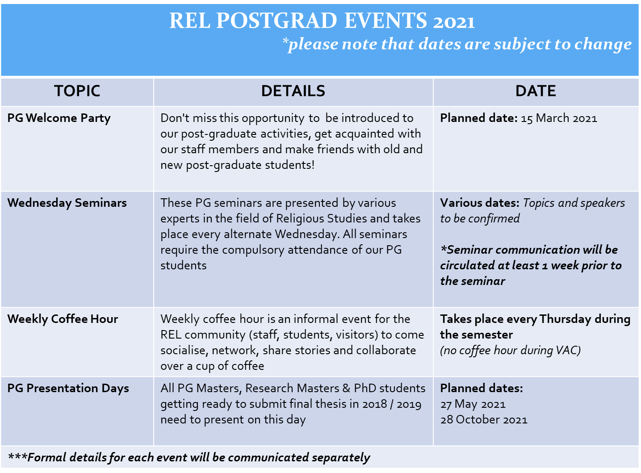

PG Presentation Day

Due to Covid-19 all Presentations for 2021 may be cancelled – the department will send communication via email in this regard.

PG Presentation Day Requirements and Workflow

The Department hosts 2 PG presentation days each year (1 per semester). They usually take place in May and October each year.

Objective of the PG Presentation

- On this day all post-graduate students (Masters by coursework, research Masters and PhDs) are required to present a piece of their work to a wider audience as a means of tracking progress.
- This is an opportunity to share ideas with colleagues and faculty staff and to receive feedback on aspects of your work from staff members and fellow PG students.
- Presenting at this event provides an exceptionally useful opportunity for:
  - training oneself in presentation skills;
  - re-thinking aspects of one's work based on constructive comments received;
  - gaining new insights and inspiration from listening to the presentation of fellow students who are working on topics that are often only apparently distant to one's own.

Obligations of PG students:
- All Masters, Research Masters and PhD students who plan to submit their thesis at the end of the year and early the next year MUST present at one of the sessions each year.

- Students who are already in the process of writing their theses can either present a draft chapter of the thesis OR some reflections on theoretical and methodological issues they have been thinking upon during their work

- Students who have just started should present their research proposals.

- Non-research students (Masters by Coursework) are also warmly encouraged to grab this opportunity to present their research in the form of a Poster (including title, research questions and a few lines about the theoretical framework). This would be an excellent way to showcase your work in the Department and receive feedback from senior students and staff.

- Research Masters and PhD’s to present each year as a way to keep track of their progress

- Students should share copies of presentations or papers prior to the day that will be circulated among staff and fellow students

Presenting at this event:

- You will be allocated at least 45minutes (30 mins + 15 mins feedback/discussion)
- A laptop and speakers will be set up for you to utilise, so please bring your presentations along on a flash OR you may bring your own laptop along
- Please remember to send a copy of your presentation or paper at least 5 days prior to the event so that this can be circulated to all staff and fellow students

Ethics Procedures

Ethics Process Flow: Student Researchers
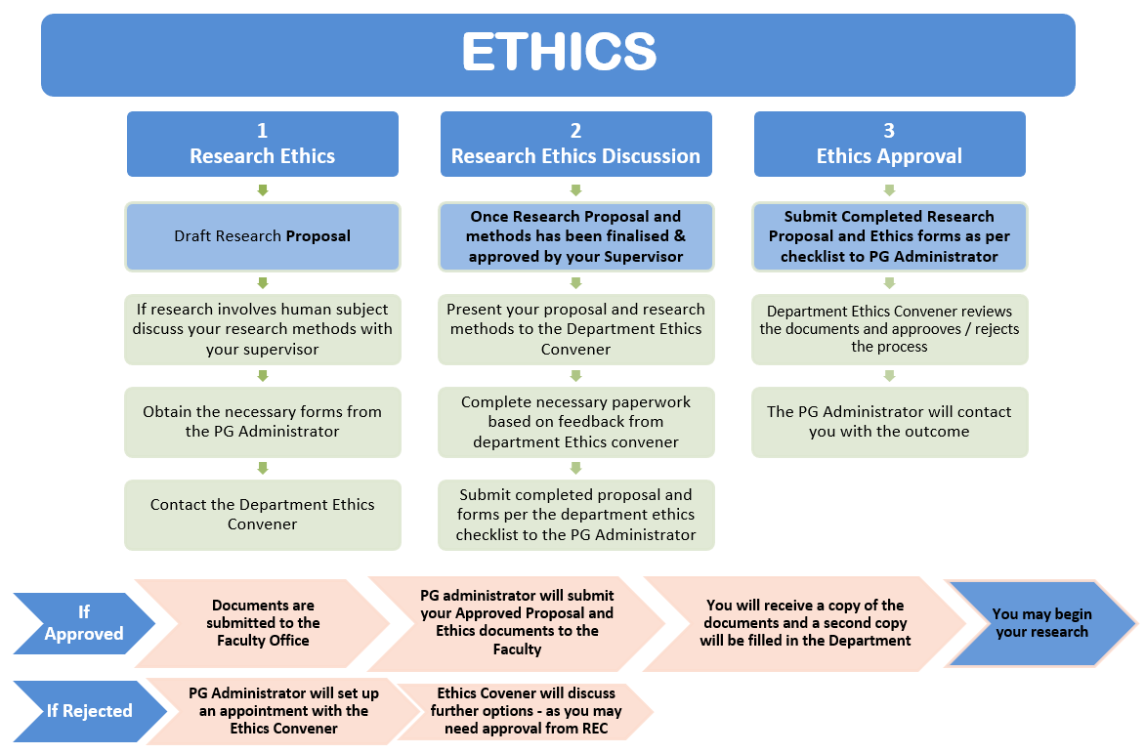

Ethics Process Flow: Other Researchers
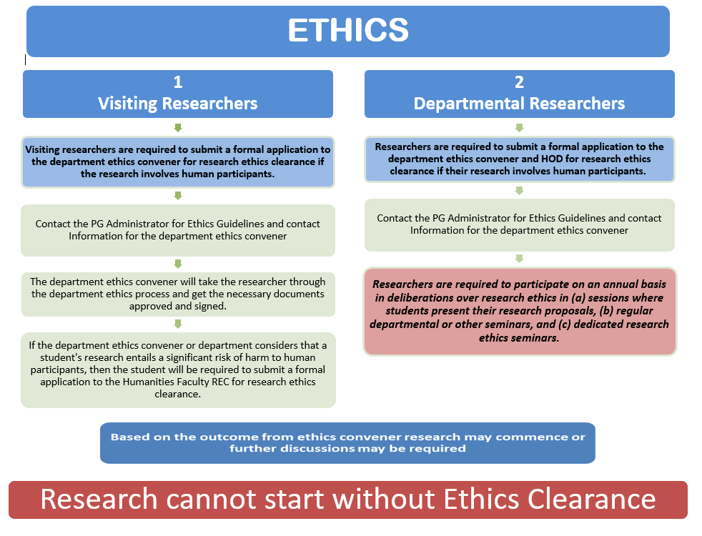
Timetable

DEPARTMENT OF RELIGIOUS STUDIES

POSTGRADUATE LECTURE TIMETABLE
FIRST SEMESTER 2020
COURSE CODE | COURSE | TIME | SCHEDULE | ROOM
REL4010F  REL5117F | Critical Terms in Religious Studies 1  Prof Abdulkader Tayob | 09H00 – 10H30 | 17 March – 09 June  Every Wednesday – 1.5hrs per week | Online via  MS Teams / Zoom
REL4110F  REL5110F | African Religious Movements  Prof Asonzeh Ukah | 11H00 – 12H30 | 17 March – 09 June  Every Wednesday – 1.5hrs per week | Online via  MS Teams / Zoom
ALL WELCOME | POSTGRADUATE SEMINAR | 13H00 – 14H00 | Takes place every alternate Wednesday | LS5.67  OR  Online via  MS Teams / Zoom
REL4113F  REL5113F | Questions in Contemporary Jewish Thought  Dr Louis Blond | 14H15 – 15H45 | 17 March – 09 June  Every Wednesday – 1.5hrs per week | Online via  MS Teams / Zoom
REL4049F  REL5115F | Islamic Studies  Prof Abdulkader Tayob | 16H00 – 17H30 | 17 March – 09 June  Every Wednesday – 1.5hrs per week | Online via  MS Teams / Zoom
REL5111F | Reading Religious Texts  A/Prof Elisabetta Porcu | OFFERED AS A READING GROUP – SCHEDULE CONFIRMED WITH SUPERVISOR |  | Online via  MS Teams / Zoom

Timetable

DEPARTMENT OF RELIGIOUS STUDIES

POSTGRADUATE LECTURE TIMETABLE
SECOND SEMESTER 2020

COURSE CODE | COURSE | TIME | SCHEDULE | ROOM
REL4012S  REL5118S | Critical Terms in Religious Studies 2  A/Prof Sa’diyya Shaikh | Various | 1st Semester Dates:  May - June  3 sessions of 1.5 hours each in the first semester:  - Fridays @ 14H30 – 16H00  - 14 May, 28 May and 18 June  2nd Semester Dates:  04 August – 27 October  7 sessions of 1.5 hours every 2nd week  - Provisionally every 2nd Wednesdays @ 09H00 – 10H30  *Note: dates & times for 2nd semester lectures may be changed & will be communicated in advance | Online via  MS Teams / Zoom
REL4046S  REL5114S | Buddhism  A/Prof Elisabetta Porcu | 11H00 -12H30 | 04 August – 27 October  Every Wednesday – 1.5hrs per week | Online via  MS Teams / Zoom
ALL WELCOME | POSTGRADUATE SEMINAR | 13H00 – 14H00 | Takes place every alternate Wednesday | LS5.67  OR  Online via  MS Teams / Zoom
REL4091S  REL5091S | Explorations in Islam  A/Prof Sa’diyya Shaikh | 14H15 – 15H45 | 04 August – 27 October  Every Wednesday – 1.5hrs per week | Online via  MS Teams / Zoom
REL5111S | Reading Religious Texts  A/Prof Elisabetta Porcu | OFFERED AS A READING GROUP – SCHEDULE CONFIRMED WITH SUPERVISOR |  | Online via  MS Teams / Zoom

